

**A**

**PROJECT REPORT**

**On**

**“E-Learning Website”**

**SUBMITTED IN PARTIAL FULFILLMENT OF THE**

**REQUIREMENT FOR THE AWARD OF THE DEGREE**

**Of**

***Bachelor of Computer Application***

*Session*

*201*

*(*

*9*

*-*

*2022*

*)*

**Guided by:**

**-**

**Submitted by:**

**-**

Mr.

Shrawan Ku

mar Sharma

Head, computer Science)

(

Prachi Vijayvargiya

(

BCA III

Year)

**Department of Computer Science**

**RNT PG College,**

**Kapasan**

**CHITTORGARH**

**(**

**Affiliated to MOHAN LAL SUKHADIYA UNIVERSITY, UDAIPUR**

**)**

**Email:**

**-**

**Rntkapasan1@gmail.com**

**Web**

**site:**

**-**

**http://rntgroup.edu.in**

# STATEMENT OF ORIGINALITY

In accordance with the requirement for the degree of **Bachelor in Computer Application,** in Faculty of **Computer Science,** wepresent this report Entitled **“E-Learning Website”.**

This report is completed under the Supervision of

**Mr.** **Shrawan kumar Sharma**

We declare that the work presented in the report is my own work except as acknowledged in the text and footnotes, and that to my knowledge this material has not been submitted either in whole or in part, for a degree at this school or at any such Institution.

**This work has not submitted elsewhere for award of other degree.**

Date: - ……. Name &Signature of Student Place:-Kapasan Prachi Vijayvargiya

(BCA III year)

I

**R.N.T. PG COLLEGE OF KAPASAN**



**(Session 2019-2022)**

**CERTIFICATE**

This is to certify that the work is being presented in Project report entitled “E-Learning Website**”** Submitted by Prachi Vijayvargiya Students of final year Bachelor of Computer Application (BCA) in partial fulfillment for award of degree of Bachelor of Computer Application (2019-2022) is a record of student’s work carried out by them under our guidance and supervision of Mr. Shrawan Kumar Sharma (Head, Computer Science) of Computer Science Department.

**This work has not been submitted elsewhere for award of any other degree.**

**Date:**

**Place: RNT PG College, Kapasan**

**Signature of Project Guide** Signature of **Project Coordinator**

**Mr. Shrawan Kumar Sharma Mr. Shrawan Kumar Sharma**

**(Head, Computer Science) (Head, Computer Science)**

# ACKNOWLEDGEMENT

It is a pleasure to represent my report on **E-Learning Wensite** as a project I would like to express my deep gratitude to my teach instructor and guide Mr. Shrawan Kumar Sharma (Head, Computer Science) for giving us all necessary encouragement and guidance for overcoming all the difficulty that I had faced in the task. I thank him to guiding us from I beginning to the end.

I am highly graceful to Dr. Afsar Ali (Principal: -RNT P.G. College Kapasan) for providing me this opportunity and support. I am highly indebted to All the Faculty member of Computer Science Department for their cooperation, guidance & Support. I am also grateful to my friends who always stood by my side giving their worthily advice in making the project.

Last but not the least to express my indebtedness to Mr. Shrawan Kumar Sharma (Head, Computer Science) the coordinator of the project for his constant motivation regarding this project.

# Abstract

**E-Learning Website** is a web-based technology that will manage the records of pass which issue by administrative. Curfew Pass Management System is an automatic system that delivers data processing at a very high speed in a systematic manner. In CPMS we use PHP and MySQL database. This is the project which keeps records of the pass which is issue by administrative.

The main objective of “**E-learning Website”** is to enhance and upgrade the existing system by increasing its efficiency and effectiveness by reducing the manual work. The Web Application improves the working methods by replacing the existing manual system with the computer-based system. This application enables the right security, where you could keep a vigilant eye on the people who are taking the access out of the premises. This Curfew Pass Management System is used to overcome the entire problem which they are facing currently, and making complete atomization of manual system to computerized system.

# Table of Contents

**Statement of Originality I**

**Recommendations II**

**Acknowledgement III**

**Abstract IV**

**Table of Contents V**

**List of Figure VII**

**List of Table VIII**

**CHAPTER 1 INTRODUCTION** 1

1.1 1

1.2 1

1.3 2

1.4 3

1.5 Web Design 3

1.6 Programming Language 4

1.6.1 HTML 5

1.6.1.1 Why HTML? 5

1.6.1.2 Applications of HTML 5

1.6.2 CSS 6

1.6.2.1 What is a CSS file? 6

1.6.2.2 about CSS Files? 7

1.6.2.3 Advantages of CSS? 7

1.6.2.4 CSS Versions? 7

1.6.2.5 Type of CSS? 8

1.6.3 PHP 8

1.6.3.1 PHP file? 9

1.6.3.2 What is MySQL? 9

1.6.3.3 Why PHP?

**CHAPTER 2 PROBLEM STATEMENTS & OBJECTIVE 12**

2.1 Problem Statements 12

2.2 Objective 12

**CHAPTER 3 IMPLEMENTATIONS 13**

3.1 Hardware Requirement 13

3.2 Software Requirement 13

3.3 DFD (Data flow diagrams) 13

3.4 DATABASE DESIGN 14

**CHAPTER 4** **RESULT 15**

CONCLUSION 25

FUTURE SCOPE 26

REFERENCES 27

# LIST OF FIGURES

Figure 1.1 Curfew on a city 2

Figure 1.2 Lockdown in India 3

Figure 3.1 DFD of Curfew E pass management system 14

Figure 4.1 Front view of curfew E-pass mgmt system 15

Figure 4.2 Login view of curfew E-pass mgmt system 15

Figure 4.3 Dashboard view of curfew E-pass mgmt system 16

Figure 4.4 Category of curfew E-pass mgmt system 16

Figure 4.5 add pass of curfew E-pass mgmt system 17

Figure 4.6 search pass of curfew E-pass mgmt system 17

Figure 4.7 Manage pass of curfew E-pass mgmt system 18

Figure 4.8 Search pass using Pass Number 18

Figure 4.9 Search pass using mobile no 19

Figure 4.10 Show pass between dates 19

Figure 4.8 Search Pass reports between dates 20

Figure 4.11 View of User Profile 20

Figure 4.12 View of User Profile details 21

Figure 4.13 View of change password details 21

Figure 4.13 View of logout Curfew e-pass mgmt system 22

# LIST OF TABLES

3.1 Hardware Requirement 13

3.2 Software Requirement 13

**CHAPTER 1**

**INTRODUCTION**

The **“E-Learning System”** has been developed to override the problems prevailing in the practicing manual system. This software is supported to eliminate and in some cases reduce the hardships faced by this existing system. Moreover in a smooth and effective manner.

The application is reduced as much as possible to avoid errors while entering the data.

It also provides error message while entering invalid data. No formal knowledge is needed for the user to use this system, as described above, can lead to error free, secure, reliable and fast management system. It can assist the user to concentrate on their other activities rather to concentrate on the record keeping. Thus it will help organization in better utilization of resources.

Every organization, whether big or small, has challenges to overcome and managing

the information of student, Assignment, Notes, Previous Year Question Paper.

Every E-learning Management System has different Assignment needs, therefore we design exclusive employee management systems that are adapted to your managerial requirements. This is designed to assist in strategic planning, and will help you ensure that your organization is equipped with the right level of information and details for your future goals. Also, for those busy executive who are always on the go, our systems come with remote access features, which will allow you to manage your workforce anytime, at all times. These systems will ultimately allow you to better manage resources.

As the term explains, technology that runs on the World Wide Web is known as **"Web Technology"**. Web technology has given enterprise businesses a broad scope to enhance their task and database with safety and mobility, so that it can be accessed from any location, all that you'd need is Internet. Another term for web technology could be **SaaS (Software as a Service)**, you'd need to pay for the technology as and how you use it. You won’t need to install any software; all you'd need is a simple signup and few details to use the technology.

A web-based solution provides users the flexibility of accessing the technology just by typing the URL in the browser. For example, when an organization needs to configure their company-owned Android devices in kiosk mode, the IT admin can manage and configure settings for a device or a fleet of devices right from a webbased console. S/he can perform the task effortlessly from their laptop/desktop and moreover, have a birds-eye view on all the devices with few simple clicks.

**1.5 Web Design**

Web design refers to the design of websites that are displayed on the internet. It usually refers to the user experience aspects of website development rather than software development. Web design used to be focused on designing websites for desktop browsers; however, since the mid-2010s, design for mobile and tablet browsers has become ever-increasingly important.

A web designer works on the appearance, layout, and, in some cases, content of a website. Appearance, for instance, relates to the colors, font, and images used. Layout refers to how information is structured and categorized. A good web design is easy to use, aesthetically pleasing, and suits the user group and brand of the website.

Many web pages are designed with a focus on simplicity, so that no extraneous information and functionality that might distract or confuse users appears.

As the keystone of a web designer’s output is a site that wins and fosters the trust of the target audience, removing as many potential points of user frustration as possible is a critical consideration.

Two of the most common methods for designing websites that work well both on desktop and mobile are responsive and adaptive design.

In **responsive design**, content moves dynamically depending on screen size; in **adaptive design**, the website content is fixed in layout sizes that match common screen sizes.

#### 1.6 Programming Language

A programming language is used to control the actions of a machine. Such a language is a properly drafted or constructed language when it is designed in such a way that through it instructions can be communicated to a computer system. Ever since the invention of computers, thousands of programming languages have been created, and more are being created every year.

The universe of programming languages is wide and knowing all or learning each one of them is neither practical nor possible. If you are a developer who is interested in learning the most useful and popular ones, then you must first know which ones of the thousands of languages to learn.

**1.6.1 HTML**

HTML stands for Hyper Text Markup Language, which is the most widely used language on Web to develop web pages. HTML was created by Berners-Lee in late 1991 but "HTML 2.0" was the first standard HTML specification which was published in 1995. HTML 4.01 was a major version of HTML and it was published in late 1999. Though HTML 4.01 version is widely used but currently we are having HTML-5 version which is an extension to HTML 4.01, and this version was published in 2012.

**1.6.1.1 Why HTML?**

Originally, HTML was developed with the intent of defining the structure of documents like headings, paragraphs, lists, and so forth to facilitate the sharing of scientific information between researchers. Now, HTML is being widely used to format web pages with the help of different tags available in HTML language

**HTML** is a MUST for students and working professionals to become a great Software Engineer specially when they are working in Web Development Domain. I will list down some of the key advantages of learning HTML:

* **Create Web site** - You can create a website or customize an existing web template if you know HTML well.
* **Become a web designer** - If you want to start a carrer as a professional web designer, HTML and CSS designing is a must skill.
* **Understand web** - If you want to optimize your website, to boost its speed and performance, it is good to know HTML to yield best results.
* **Learn other languages** - Once you understands the basic of HTML then other related technologies like java script, php, or angular are become easier to understand.

##### 1.6.1.2 Applications of HTML

As mentioned before, HTML is one of the most widely used language over the web.

I'm going to list few of them here.

**Web pages development** - HTML is used to create pages which are rendered over the web. Almost every page of web is having html tags in it to render its details in browser.

* **Internet Navigation** - HTML provides tags which are used to navigate from one page to another and is heavily used in internet navigation.
* **Responsive UI** - HTML pages now-a-days works well on all platform, mobile, tabs, desktop or laptops owing to responsive design strategy.
* **Offline support-** HTML pages once loaded can be made available offline on the machine without any need of internet.
* **Game developmen**t- HTML5 has native support for rich experience and is now useful in gaming development arena as well.

### 1.6.2 CSS

Cascading Style Sheets, fondly referred to as CSS, is a simple design language intended to simplify the process of making web pages presentable.

Cascading Style Sheets, fondly referred to as CSS, is a simple design language intended to simplify the process of making web pages presentable.

**CSS Example**

<style> body {background-color:lightblue; text-align:center;} h1 {color:blue; font-size:40px;} p {font-family:verdana; font-size:20px;}

</style>

**1.6.2.1 What is a CSS file?**

* A CSS file is a cascading style sheet (CSS) file used to format the contents of a webpage.
* It contains customized, global properties for how to display HTML elements.
* CSS files can define the size, color, font, line spacing, indentation, borders, and location of HTML elements.

**1.6.2.2 about CSS Files?**

* The Cascading Style Sheet file type, file format description, and Mac, Windows, Linux, Android, and iOS programs listed on this page have been individually researched and verified by the FileInfo team.
* We strive for 100% accuracy and only publish information about file formats that we have tested and validated.

**1.6.2.3 Advantages of CSS?**

* **CSS saves time** − You can write CSS once and then reuse same sheet in multiple HTML pages. You can define a style for each HTML element and apply it to as many Web pages as you want.
* **Pages load faster** − If you are using CSS, you do not need to write HTML tag attributes every time. Just write one CSS rule of a tag and apply it to all the occurrences of that tag. So less code means faster download times
* **Easy maintenance** − To make a global change, simply change the style, and all elements in all the web pages will be updated automatically.
* **Superior styles to HTML** − CSS has a much wider array of attributes than HTML, so you can give a far better look to your HTML page in comparison to HTML attributes.
* **Multiple Device Compatibility** − Style sheets allow content to be optimized for more than one type of device. By using the same HTML document, different versions of a website can be presented for handheld devices such as PDAs and cell phones or for printing.
* **Global web standards** − Now HTML attributes are being deprecated and it is being recommended to use CSS. So its a good idea to start using CSS in all the HTML pages to make them compatible to future browsers.

**1.6.2.4 CSS Versions?**

* Cascading Style Sheets level 1 (CSS1) came out of W3C as a recommendation in December 1996. This version describes the CSS language as well as a simple visual formatting model for all the HTML tags.

CSS2 became a W3C recommendation in May 1998 and builds on CSS1. This version adds support for media-specific style sheets e.g. printers and aural devices, downloadable fonts, element positioning and tables

**1.6.2.5 Type of CSS?**

Cascading Style Sheet (CSS) is used to set the style in web pages which contain HTML elements. It sets the background color, font-size, font-family, color, etc property of elements in a web pages.

There are three types of CSS which are given below:…..

* **Inline CSS:** Inline CSS contains the CSS property in the body section attached with element is known as inline CSS. This kind of style is specified within an HTML tag using style attribute.
* **Internal or Embedded CSS:** This can be used when a single HTML document must be styled uniquely. The CSS rule set should be within the HTML file in the head section i.e the CSS is embedded within the HTML file.
* **External CSS:** External CSS contains separate CSS file which contains only style property with the help of tag attributes (For example class, id, heading … etc). CSS property written in a separate file with .css extension and should be linked to the HTML document using link tag. This means that for each element, style can be set only once and that will be applied across web pages.

### 1.6.3 PHP

PHP(recursive acronym for “PHP : Hypertext Preprocessor”) is a widely-used Open Source general-purpose scripting language that is especially suited for Web development and can be embedded into HTML.

* PHP stands for **P**HP: **H**ypertext **P**reprocessor.
* PHP is a server-side scripting language.
* PHP scripts are executed n the server.

PHP supports many databases (MySql, Informix, Oracle, Sybase, Solid, PostgreSQL, Generic ODBC, etc.) • PHP is open source software.

* PHP is free to download and use.

**A Introductory Example :**

<html>

<head>

<title> Example of PHP program</title>

</head>

<body>

<?php

Echo “This is PHP program”;

?>

</body>

</html>

**1.6.3.1 PHP file?**

* PHP files can contain text, HTML tags and scripts.
* PHP files are returned to the browser as plain HTML.
* PHP files have a file extension of “.php”, “.php3”, or “.phtml”.

**1.6.3.2 What is MySQL?**

* MySQL is a database server.
* MySQL is ideal for both small and large applications.
* MySQL supports standered SQL.
* MySQL compiles on a number of platforms.
* MySQL is free to download and use.

PHP combined with MySQL are cross-platform (you can develop in windows and serve in a UNIX platform).

**1.6.3.3 Why PHP?**

* PHP runs on different platforms (Windows, Linux, Unix, etc.).
* PHP is compatible with almost all servers used today (Apache, IIS, etc.).
* PHP is Free to download from the official PHP resource
* PHP is easy to learn and runs efficiently in the server side.

There are three main areas where PHP scripts are used.

* **Server-side Scripting:** This is the most traditional and main target field for PHP. We need three things to make this work. The PHP parser (CGI or server module), a web server and a web browser. We need to run the web server, with a connected PHP installation.
* **Command line Scripting:** We can make a PHP script to run it without any server or browser. We only need the PHP parser to use it this way. This type of usages is ideal for scripts regularly executed using cron (on *nix or Linux) or Task Scheduler(on Windows).
* **Writing Desktop Application:** PHP is probably not the very best language to create a desktop application with a graphical user interface, but if we know PHP very well, and would like to use some advanced PHP features in your client-side application we can also use PHP-GTK to write such programs. PHP can be used on all major operating systems, including Linux, /many UNIX variants (including HP-UX, Solaris and OpenBSD), Microsoft Windows, Mac, OS X, RISC OS, and probably others. PHP has also support for most of the web servers today.
* **Dealing with forms:** One of the most powerful features of PHP is the way it handles HTML forms. The basic concept that is important to understand is that any from elements will automatically be available to our PHP script.
* **General Installation Considerations:** For the first and most common form, we need three things: PHP itself, a web server and a web browser. We probably already have a web server (e.g. Apache on Linux and MacOS X, IIS on Windows). We may also rent web space at a company.

**Security:** PHP is a powerful language and the interpreter, whether included in a web server as a module or executed as a separate CGI binary, is able to access files, execute commands and open network connections on the server. These properties make anything run on a web server insecure by default. PHP is designed specifically to be a more secure language for writing CGI programs that perl or C, and with correct selection of compile-time and runtime configuration option, and proper coding practice, it can give us exactly the combination of freedom and security we need.

As there are many different ways of utilizing PHP, there are many configuration options controlling its behavior. A large selection of option guarantees you can use PHP for a lot of purpose, but is also means there are combinations of these options and server configurations that result in an insecure setup.

The configuration flexibility of PHP is equally rivaled by the code flexibility. PHP can be used to build complete server applications, with all the power of a shell user, or it can be used for simple server-sideincludes with little risk in a tightly controlled environment. How we build that environment, and how secure it is, is largely up to the PHP developer.

**CHAPTER 2 PROBLEM STATEMENTS & OBJECTIVE**

## 2.1 Problem Statements

## 2.2 Objective

* To provide notes, syllabus and previous year exam’s questions.
* To maintain the document in electronic form.

To maintain the document in electronic form.

**CHAPTER 3 IMPLEMENTATIONS**

In lockdown the people as stuck in everywhere and they have no option to move in own place, than the government is start a pass system but this system is very complex and difficult to follow also it’s require lot of time and paper work.

The curfew pass management system is based on php/MySql web application. it easy to install and easy to generate a valid pass for time, also the admin check all pas details ,search ,edit ,delete ,view the old pass .

## 3.1 Hardware Requirement

Table 3.1 Hardware Requirement

|  |  |
| --- | --- |
| Name of Hardware | Minimum Requirement |
| Processor | P4 or higher |
| Ram | 512 MB |
| Hard Disk | 80 GB |
| Other hardware devices | Keyboard, mouse, monitor etc. |

## 3.2 Software Requirement

Table 3.2 Software Requirement

|  |  |
| --- | --- |
| Name of Software | Minimum Requirement |
| Frontend | Google Crome |
| Language | Php |
| Backend | MySql |

## 3.3 DFD (Data flow diagrams)

Data flow diagrams are used to graphically represent the flow of data in a business information system. DFD describes the processes that are involved in a system to transfer data from the input to the file storage and reports generation.

Data flow diagrams can be divided into logical and physical. The logical data flow diagram describes flow of data through a system to perform certain functionality of a business. The physical data flow diagram describes the implementation of the logical data flow.

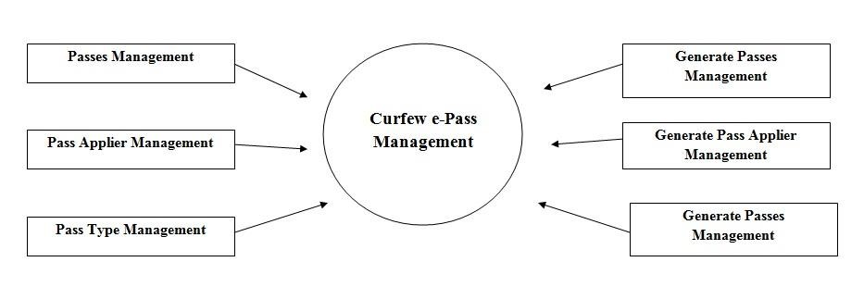

Figure 3.1 DFD of Curfew E pass management system

## 3.4 DATABASE DESIGN

The data in the system has to be stored and retrieved from database. Designing the database is part of system design. Data elements and data structures to be stored have been identified at analysis stage. They are structured and put together to design the data storage and retrieval system.

A database is a collection of interrelated data stored with minimum redundancy to serve many users quickly and efficiently. The general objective is to make database access easy, quick, inexpensive and flexible for the user. Relationships are established between the data items and unnecessary data items are removed. Normalization is done to get an internal consistency of data and to have minimum redundancy and maximum stability. This ensures minimizing data storage required, minimizing chances of data inconsistencies and optimizing for updates. The MS Access database has been chosen for developing the relevant databases.

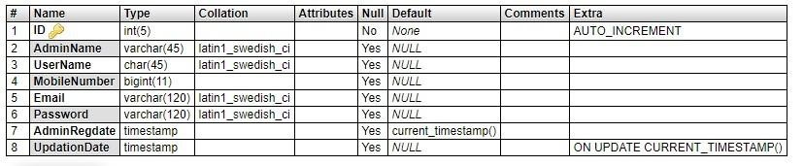

**CHAPTER 4**

**RESULT**

In this section we can display Result snapshot step by step and working technique

4.1 Snapshot of main view: - the figure 4.1 is show the front and first view of project



Figure 4.1 Front view of E-Learning Website (Knowledge Bank)

Figure 4.2 Course Page of E-learning Website

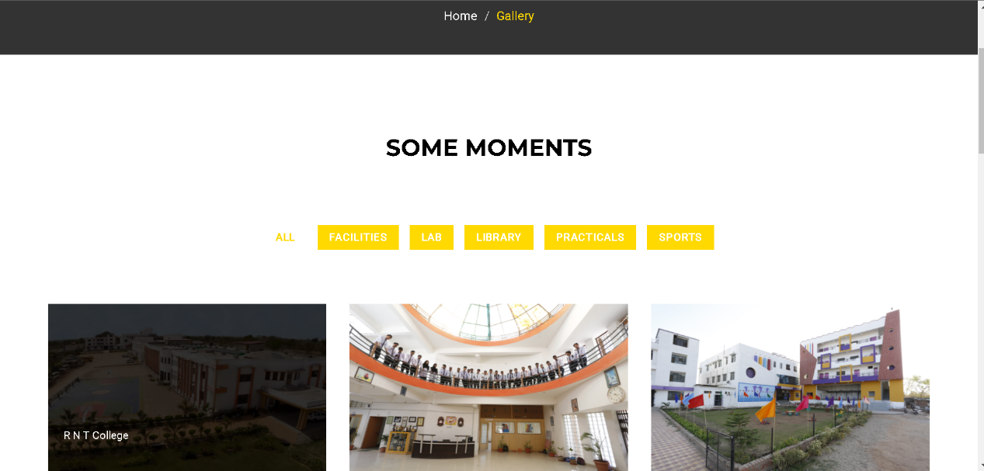

Figure 4.3 Gallery view of E-Learning Website



Figure 4.4 Books View of E-Learning Website

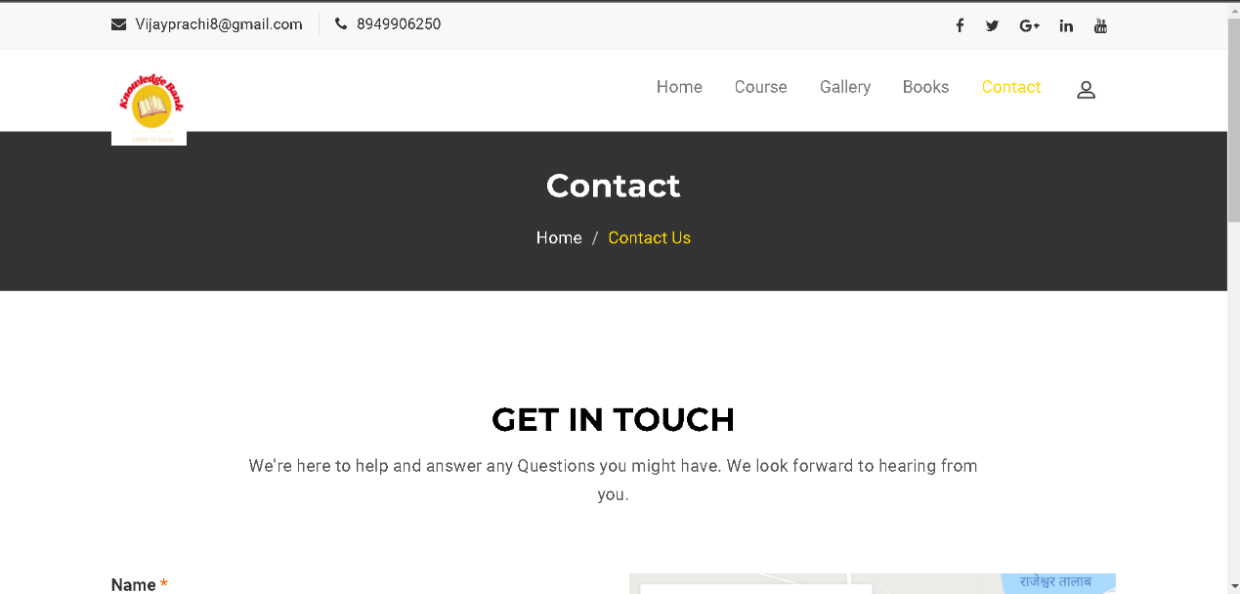

Figure 4.5 Contact Us view of E-learning Website

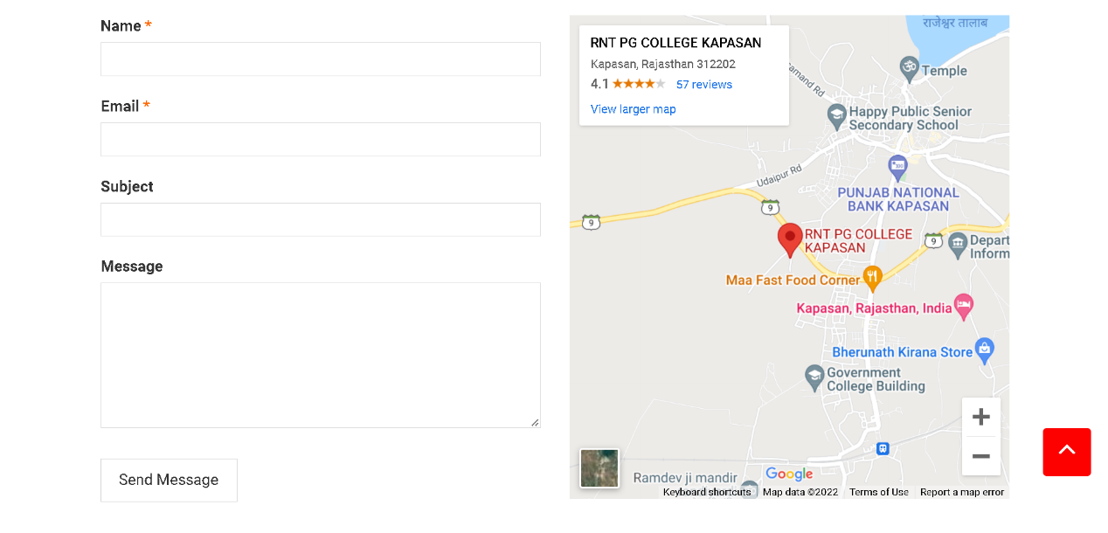

Figure 4.6 Contact Page (Send Message)

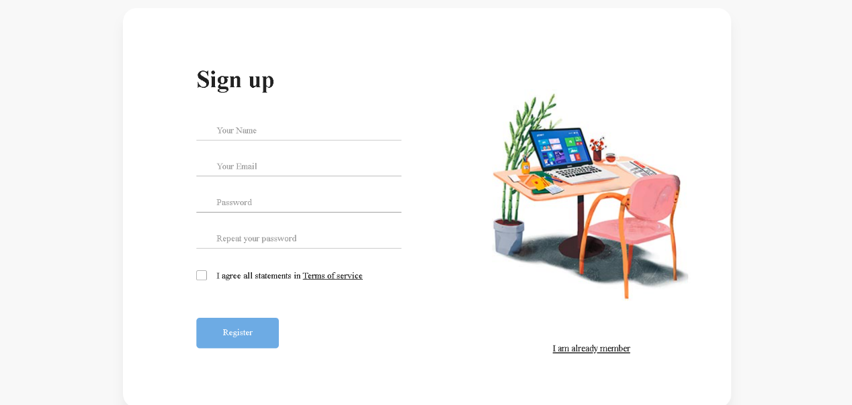

Figure 4.7 Register Page of E-learning Website

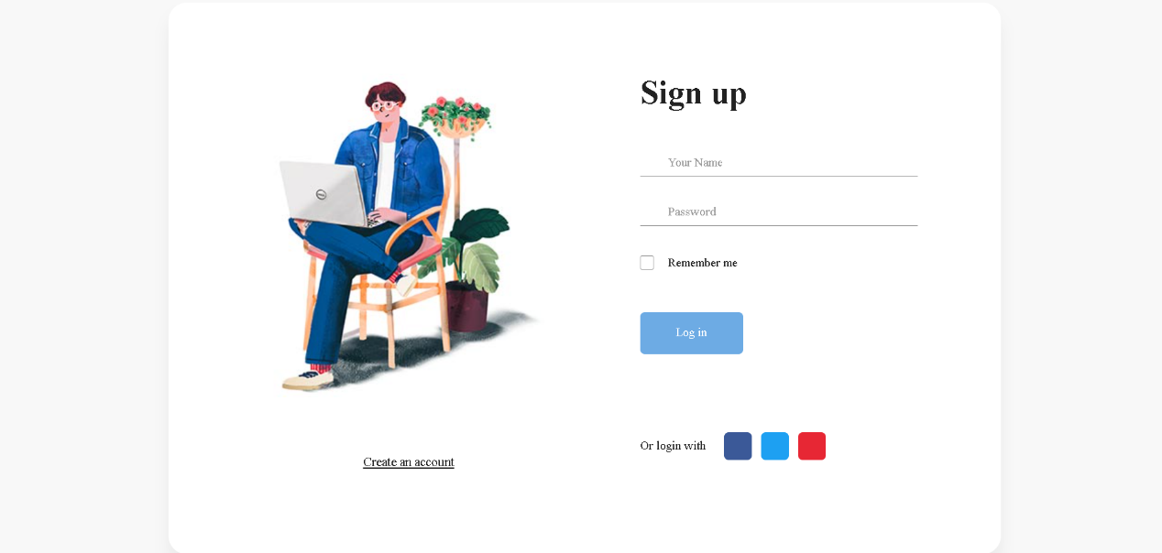

Figure 4.8 Sign Up Page of E-learning

**Conclusion**

Curfew E-pass mgmt system is very helpful for those people to requires emergency passes for traveling like any medical issue ,accidental issue or any other emergency. The web based of curfew E-pass mgmt system directly generates a pass to people without any hard work. In this project the using terminology PhP and MySql is very easy and helpful for end user.

## Future work

In future we try to develop same terminology in advance programming like java and python also we try to develop a mobile based application using android with add some more extra features.

## Reference

1. Oki Electric Industry Co. Ltd. “US6734783 B1” by- Noriyoshi Anbai “Gate Management System”.
2. Hitachi International Ltd. “US7755480 B2” by- Shoji Suzuki, Hiroshi Hanyu, Fumio Enmei “Smart Security System”.
3. Honeywell International Inc. “US7362210 B2” by- Rida M. Hamza, David W. Meyers “System For Gate Access Control”.
4. Korean Society of Computer Information by- Kwon, Ki-Hyeon; Lee Hyung-Bong

“Gate Management System by Face Recognition using Smart Phone”.